**OX Apache Plugin**

**Install Guide**

**( Windows 7 x64, Ubuntu 12.04, CentOS 6.4 )**



<https://www.gluu.org/>

Malin Imna

[malinimna@gluu.org](mailto:malinimna@gluu.org2)

**Content :**

**Windows 7 (64bit)** 1

**Memcached Installation** 1

**Apache 2.4 Installation** 1

**PHP 5.5 Installation** 2

**PHP Memcache Installation** 3

**Shibboleth-SP Installation** 4

**OX Plugin Installation** 5

**Ubuntu 12.04** 8

**Memcached Installation** 8

**Apache 2 Installation** 8

**PHP 5 Installation** 9

**PHP Memcache Installation** 9

**Shibboleth-SP Installation** 9

**OX Plugin Installation** 10

**CentOS 6.4** 12

**Memcached Installation** 12

**HTTPD Installation** 12

**PHP 5 Installation** 14

**PHP Memcache Installation** 14

**Shibboleth-SP Installation** 14

**OX Plugin Installation** 15

**Appendix** 17

**ox.conf** 17

**Figure :**

**Figure 1. Memcached Install** 1

**Figure 2. Apache 2.4 First Page** 2

**Figure 3. Shibboleth SP Installation** 4

**Figure 4. OX Success Page** 7

**Figure 5. Apache 2 First Page** 9

**Figure 6. OX Success Page** 11

**Figure 7. SSL Configuration** 13

**Figure 8. HTTPD First Page** 14

**Figure 9. OX Success Page** 16

# **Windows 7 (64bit)**

## **Memcached Installation**

1. Download Memcached from

<https://svn.gluu.info/repository/oauth2ApacheHTTPD/ETC/Windows(x64)/memcached-win64.zip>

2. Run command prompt :

:> memcached –d install

:> memcached –d start

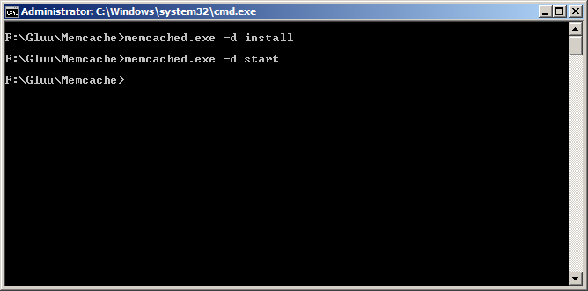

**Figure 1. Memcached Install**

## **Apache 2.4 Installation**

1. Download Apache2.4 from:

<https://svn.gluu.info/repository/oauth2ApacheHTTPD/ETC/Windows(x64)/httpd-2.4.6-x64.zip>

2. Decompress httpd-2.4.6-x64.zip into C:/Apache24.

3. Edit “C:\Windows\System32\drivers\etc\hosts”

127.0.0.1 www.myexample.com

(“www.myexample.com” : Name of Host Server. Could set by yourself.)

4. Edit “C:\Apache24\conf\httpd.conf”

*Fix :*

#ServerName www.example.com:80->ServerName www.myexample.com:80

5. Run command prompt (Start->Run->cmd)

:> cd C:\Apache24\bin

:> httpd –k install

:> httpd –k start

6. Test if Apache is installed or not. Open your web browser and use "www.myexample.com". If you see something like below image; you are done!

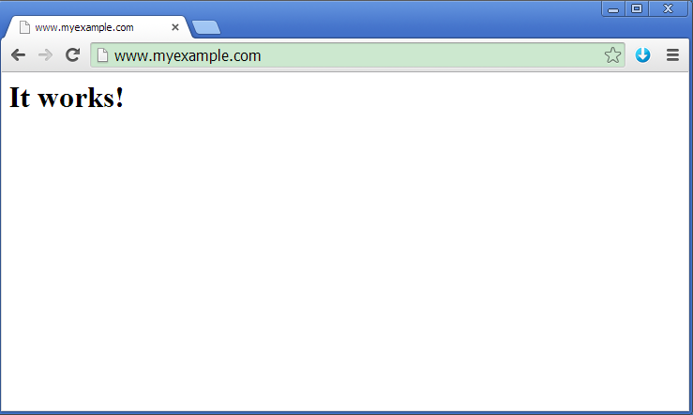

**Figure 2. Apache 2.4 First Page**

## **PHP 5.5 Installation**

1. Download PHP5.5 from:

[https://svn.gluu.info/repository/oauth2ApacheHTTPD/ETC/Windows(x64)/](https://svn.gluu.info/repository/oauth2ApacheHTTPD/ETC/Windows(x64)/php-5.5.9-Win32-VC11-x64.zip)php-5.5.16-Win32-VC11-x64.zip

2. Decompress php-5.5.16-Win32-VC11-x64.zip into C:/PHP.

3. Rename “C:\PHP\ php.ini-development” to php.ini

4. Edit “C:\PHP\php.ini”

*Fix :*

; extension_dir = "ext" -> extension_dir = "C:\PHP\ext"

5. Restart Apache2.4 on command prompt

:> httpd –k restart

## **PHP Memcache Installation**

1. Download PHP5.5 from:

<https://svn.gluu.info/repository/oauth2ApacheHTTPD/ETC/Windows(x64)/>[php_memcache-3.0.8-5.5-ts-vc11-x64.zip](https://svn.gluu.info/repository/oauth2ApacheHTTPD/UMA/Windows(x64)/php_memcache-3.0.8-5.5-ts-vc11-x64.zip)

2. Decompress php-memcache-3.0.8-5.5-ts-vc11-x64.zip into C:/PHP/memcache.

3. Copy memcache/php_memcache.dll into ext/

:> cd C:\PHP\

:> copy memcache\php_memcache.dll ext\

4. Edit “C:\PHP\php.ini”

*Add :*

extension=php_memcache.dll

5. Edit “C:\Apache24\conf\httpd.conf”

*Add :*

LoadModule php5_module "C:/PHP/php5apache2_4.dll"

PHPIniDir "C:/PHP/"

AddType application/x-httpd-php .php

AddHandler application/x-httpd-php .php

6. Restart Apache2.4 on command prompt

:> httpd –k restart

## **Shibboleth-SP Installation**

1. Download MSI of Shibboleth-SP from:

<http://shibboleth.net/downloads/service-provider/latest/win64/shibboleth-sp-2.5.3-win64.msi>

2. Start installation by double clicking the file “shibboleth-sp-2.5.3-win64.msi”

3. License agreement

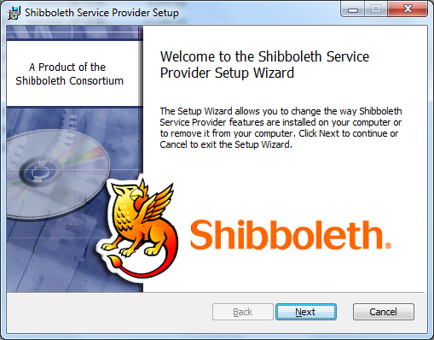

**Figure 3. Shibboleth SP Installation**

4. Destination folder (by default it is: C:\opt\shibboleth-sp\)You can select any directory, but this is best to follow the tree \opt\shibboleth-sp\

5. Click Next, finish installation.

6. Copy C:\opt\shibboleth-sp\etc\shibboleth\apache24.config into C:\Apache24\conf\extra

:> copy C:\opt\shibboleth-sp\etc\shibboleth\apache24.config C:\Apache24\conf\extra

7. Edit “C:\Apache24\conf\httpd.conf”

*Add :*

Include conf/extra/apache24.config

8. Restart Windows OS.

9. Restart Apache2.4 on command prompt

:> httpd –k restart

## **OX Plugin Installation**

1. Download OX package from:

<https://svn.gluu.info/repository/oauth2ApacheHTTPD/ETC/Windows(x64)/ox.zip>

2. Decompress ox.zip into C:/ox.

3. Copy C:\ox\mod_ox.so into C:\Apache24\modules\

4. Copy C:\ox\ox.conf into C:\Apache24\conf\extra\

5. Edit “C:\Apache24\conf\extra\apache24.config”

*Add :*

<Location /shibd>

AuthType shibboleth

ShibRequestSetting requireSession 1

ShibUseHeaders on

Require valid-user

</Location>

6. Copy all directories in C:\ox\htdocs into C:\Apache24\htdocs

7. Copy all files in C:\ox\shibd\ into C:\opt\shibboleth-sp\etc\shibboleth\

8. Open “C:\opt\shibboleth-sp\etc\shibboleth\ shibboleth2.xml” and check the following lines.

<!-- Chains together all your metadata sources. -->

<MetadataProvider type="Chaining">

<MetadataProvider type="XML" file="C:/opt/shibboleth-sp/etc/shibboleth/idp-metadata.xml"/>

</MetadataProvider>

… …

<!-- TODO is password needed? -->

<CredentialResolver type="File" key="C:/opt/shibboleth-sp/etc/shibboleth/spkey.key"

certificate="C:/opt/shibboleth-sp/etc/shibboleth/spcert.crt" />

(If you install Shibd SP into any other directory, please adjust RED paths)

9. Edit “C:\Apache24\conf\httpd.conf”

*Add :*

LoadModule ox_module modules/mod_ox.so

<IfModule ox_module>

Include conf/extra/ox.conf

</IfModule>

10. Restart Apache2.4 on command prompt

:> httpd –k restart

11. Download OXD package from:

<https://svn.gluu.info/repository/oauth2ApacheHTTPD/ETC/Oxd.tar.gz>

Decompress Oxd.zip into C:/Oxd and run Oxd server.

:> cd C:/Oxd

:> autorun(win).bat

12. On web browser, goto www.myexample.com/ox

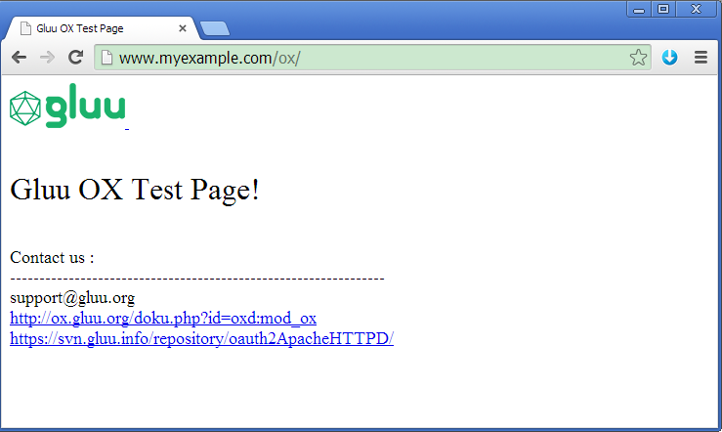

**Figure 4. OX Success Page**

# **Ubuntu 12.04**

## **Memcached Installation**

1. First, make sure your system is up to date

# sudo apt-get update

# sudo apt-get upgrade

2. Install Memcached via apt-get

# sudo apt-get install memcached

## **Apache 2 Installation**

1. Install Apache2 via apt-get

# sudo apt-get install apache2

# sudo a2enmod ssl

# sudo a2ensite default-ssl

2. Edit “/etc/hosts”

127.0.0.1 www.myexample.com

(“www.myexample.com” : Name of Host Server. Could set by yourself.)

3. Restart Apache2 service

# sudo service apache2 restart

4. On web browser, go to https://www.myexample.com

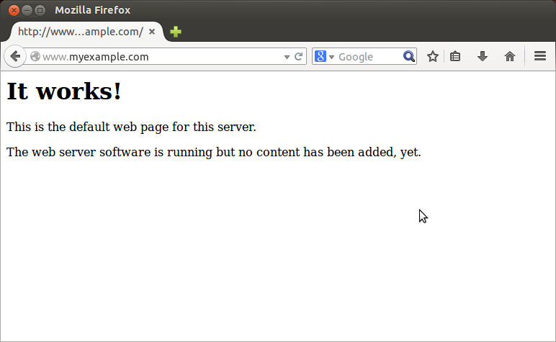

**Figure 5. Apache 2 First Page**

## **PHP 5 Installation**

1. Install PHP5 via apt-get

# sudo apt-get install php5

# sudo apt-get install libapache2-mod-php5

# sudo service apache2 restart

## **PHP Memcache Installation**

1. Install PHP memcache via apt-get

# sudo apt-get install php5-memcache

# sudo service apache2 restart

## **Shibboleth-SP Installation**

1. Install Shibboleth SP via apt-get

# sudo apt-get install libapache2-mod-shib2

# sudo a2enmod shib2

# sudo service apache2 restart

## **OX Plugin Installation**

1. Install needed packages via apt-get

# sudo apt-get install libtool automake g++ libcurl4-openssl-dev apache2-prefork-dev

2. Download OX package from:

[https://svn.gluu.info/repository/oauth2ApacheHTTPD/MOD_OX/Package/](https://svn.gluu.info/repository/oauth2ApacheHTTPD/UMA/)mod_ox-0.1.tar.gz

3. Decompress mod_ox-0.1.tar.gz and compile OX.

# tar –xzvf mod_ox-0.1.tar.gz

# cd mod_ox

# sudo chmod 755 autogen.sh

# ./autogen.sh

# ./configure && make && sudo make install

# sudo cp ox.conf /etc/apache2/mods-available/

# sudo ln -s /etc/apache2/mods-available/ox.conf /etc/apache2/mods-enabled/

# sudo cp –r copies.into.htdocs/* /var/www/html/

4. Copy Shibboleth SP config files into Shibboleth-SP

# sudo cp –f copies.into.htdocs/shibd/conf/* /etc/shibboleth/

5. Make “/etc/apache2/mods-avaliable/shib2.conf”

# sudo gedit /etc/apache2/mods-available/shib2.conf

*Add :*

<Location /shibd>

AuthType shibboleth

ShibRequestSetting requireSession 1

ShibUseHeaders on

Require valid-user

</Location>

# sudo ln –s /etc/apache2/mods-available/shib2.conf /etc/apache2/mods-enabled/

6. Download Oxd Server and start Run.

<https://svn.gluu.info/repository/oauth2ApacheHTTPD/ETC/>Oxd.tar.gz

# sudo service memcached restart

# sudo service shibd restart

# sudo service apache2 restart

# tar –xzvf Oxd.tar.gz

# cd oxd

# sudo apt-get install openjdk-7-jre-headless

# sudo chmod 755 autorun.sh

# sudo ./autorun.sh

7. On web browser, goto www.myexample.com/ox

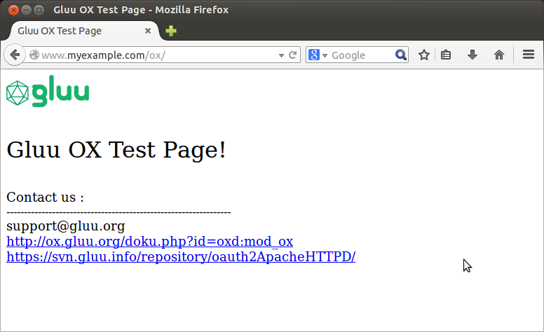

**Figure 6. OX Success Page**

# **CentOS 6.4**

## **Memcached Installation**

1. First, you make sure your system is up to date

# sudo yum update

# sudo yum upgrade

2. Disable SELINUX and Firewall

<http://sharadchhetri.com/2013/02/27/how-to-disable-selinux-in-red-hat-or-centos/>

3. Install Memcached via yum

# sudo yum install memcached

## **HTTPD Installation**

1. Install HTTPD via yum

# sudo yum install httpd openssl

# sudo yum install mod_ssl

# sudo mkdir /etc/httpd/ssl

# sudo openssl req -x509 -nodes -days 365 -newkey rsa:2048 -keyout /etc/httpd/ssl/apache.key -out /etc/httpd/ssl/apache.crt

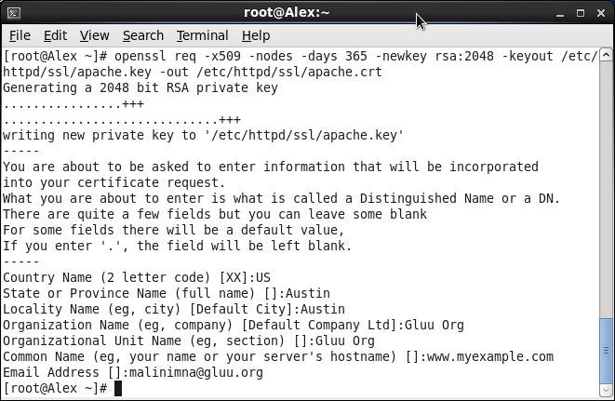

**Figure 7. SSL Configuration**

2. Open up the SSL config file :

# sudo vim /etc/httpd/conf.d/ssl.conf

Uncomment the DocumentRoot and ServerName line and replace example.com with your DNS approved domain name or server IP address (it should be the same as the common name on the certificate. In this document “www.myexample.com”):

ServerName www.myexample.com:443

Find the following three lines, and make sure that they match the extensions below:

SSLEngine on

SSLCertificateFile /etc/httpd/ssl/apache.crt

SSLCertificateKeyFile /etc/httpd/ssl/apache.key

3. Restart HTTPD service

# sudo service httpd restart

4. On web browser, go to https://www.myexample.com

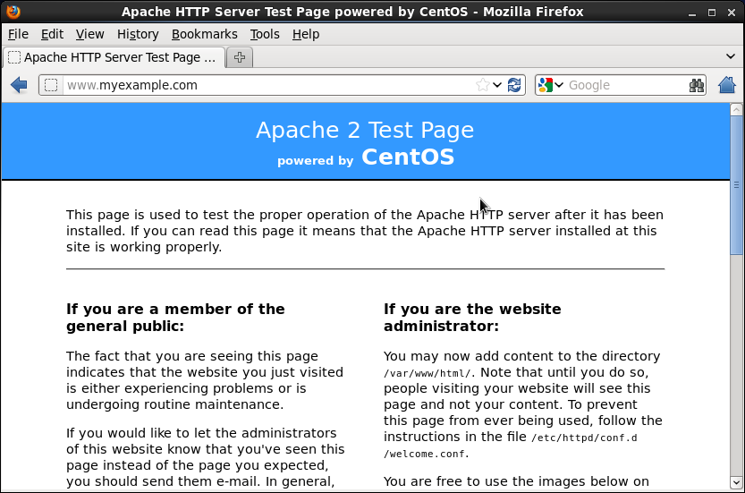

**Figure 8. HTTPD First Page**

## **PHP 5 Installation**

1. Install PHP5 via yum

# sudo yum install php

# sudo service httpd restart

## **PHP Memcache Installation**

1. Install PHP memcache via yum

# sudo yum install php-pecl-memcache

# sudo service httpd restart

## **Shibboleth-SP Installation**

1. Install Shibboleth SP via yum

<https://tuakiri.ac.nz/confluence/display/Tuakiri/Installing+Shibboleth+2.x+SP+on+RedHat+based+Linux>

# sudo wget http://download.opensuse.org/repositories/security://shibboleth/CentOS_CentOS-6/security:shibboleth.repo -P /etc/yum.repos.d

# sudo yum install shibboleth

# sudo service shibd restart

# sudo service httpd restart

## **OX Plugin Installation**

1. Install needed packages via apt-get

# sudo yum install libtool automake gcc-c++ httpd-devel

2. Download OX package from:

[https://svn.gluu.info/repository/oauth2ApacheHTTPD/MOD_OX/Package/](%20https://svn.gluu.info/repository/oauth2ApacheHTTPD/MOD_OX/Package/)mod_ox-0.1.tar.gz

3. Decompress mod_ox-0.1.tar.gz and compile OX.

# tar –xzvf mod_ox-0.1.tar.gz

# cd mod_ox

# sudo chmod 755 autogen.sh

# ./autogen.sh

# ./configure && make && sudo make install

# sudo cp ox.conf /etc/httpd/conf.d/

# sudo cp –r copies.into.htdocs/* /var/www/html/

4. Copy Shibboleth SP config into Shibboleth-SP

# sudo cp –f copies.into.htdocs/shibd/conf/* /etc/shibboleth/

5. Edit “/etc/httdp/conf.d/shibd.conf”

*Add :*

<Location /shibd>

AuthType shibboleth

ShibRequestSetting requireSession 1

ShibUseHeaders on

Require valid-user

</Location>

6. Download Oxd Server and start Run.

<https://svn.gluu.info/repository/oauth2ApacheHTTPD/ETC/Oxd.tar.gz>

# sudo service memcached restart

# sudo service shibd restart

# sudo service httpd restart

# tar –xzvf Oxd.tar.gz

# cd oxd

# sudo yum install java7

# sudo chmod 755 autorun.sh

# sudo ./autorun.sh

7. On web browser, goto www.myexample.com/ox

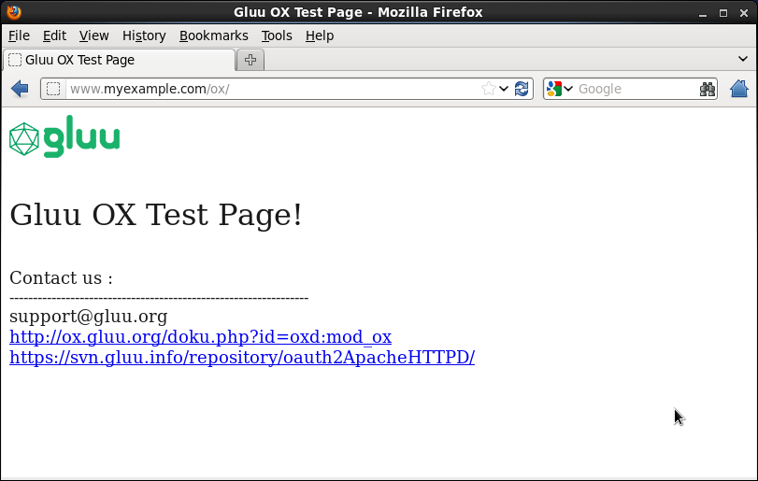

**Figure 9. OX Success Page**

# **Appendix**

## **ox.conf**

<DirectoryMatch "/ox">

AuthType Gluu_ox

Require valid-user

# Connect|SAML

AuthnType Connect

# Cookie Path

CookiePath /ox

# Needed only if AuthnType=Connect

RequestedACR https://schema.gluu.org/openid/acr/method/saml

# Needed only if AuthnType=SAML

SAMLRedirectUrl http://www.myexample.com/secure/redirect.php

# General

OxdHostAddr 127.0.0.1

OxdPortNum 8099

MemcachedHostAddr 127.0.0.1

MemcachedPortNum 11211

ClientCredsPath /var/www/html/providence/seed.gluu.org-client_creds.json

SendHeaders on

# OpenID Connect Required - needed for both UMA and OpenID Connect

ConnectDiscoveryUrl https://sso-dev.legacydataaccess.com/.well-known/openid-configuration

ApplicationLoginUrl https://www.myexample.com/ox/oxauth/login

ClientName myCLIENT

# UMA

UmaDiscoveryUrl https://sso-dev.legacydataaccess.com/.well-known/uma-configuration

UmaResourceName TestResource

UmaRsHost www.myexample.com

UmaAmHost sso-dev.legacydataaccess.com "https://schema.legacydataaccess.com/uma/providence"

# Logout

ApplicationDestinationUrl http://www.myexample.com/ox/dest.html

ApplicationLogoutUrl http://www.myexample.com/ox/logout1

ApplicationPostLogoutUrl https://idpdev.mediaocean.com/oxauth/seam/resource/restv1/oxauth/end_session

ApplicationLogoutRedirectUrl http://www.myexample.com/ox/

</DirectoryMatch>

Please refer <http://ox.gluu.org/doku.php?id=oxd:mod_ox> .